**PYTHON LAB-1**

**Team Members:**

[Abdulmuhaymin Zakari](https://umkc.instructure.com/courses/50945/users/35295) - 30

Aneesh Anne - 2

Sahithya Gadde – 5

**Introduction:**

This lab assignment focuses on basic concepts of python and machine learning.

**Objective:**

The main objective of this lab assignment is to apply the concepts which we have learned in the course practically so that one can gain in-depth knowledge and practical experience in the concepts of python and machine learning like dictionaries, sets, tuples, lists, different classification techniques like Naïve Bayes, KNN, SVM, K-Means Clustering, Multiple Linear Regression etc.

**Problem-1:**

**Approach:**

Here we have defined two functions and a list. The same problem that given in the lab assignment is passed as and argument to the function we've created to return a list that contains every possible subset of the given list. Taking this algorithm from reliable resource, the code implementation on python works as expected with a small changes on the returned list to not add any previously added value as requested in the lab assignment. This clearly obvious on the temp lists in the subsetsOf() method.**A screenshot of a cell phone
**

**Problem-2:**

**Approach:**

Here we have defined two dictionaries, concatenated and sorted the values stored in these dictionaries by creating two functions main and ToConc(). In this main function we have created two dictionaries and called the function ToConc() by passing the values stored in dictionary. And in this function we have initiated a counter and called the subclass of dictionary for sorting the values stored in the dictionary.

**Problem-3**

**Approach:**

Here we have written codefor airline booking reservation system and used the concepts of class, method overriding.

**Problem 4:**

**Approach:**

Using Beautiful Soap we have fetched the course name and overview of the course from the given URL. We have extracted the title of the course and course description which are in the tags span, p and class title, courseblockdesc respectively and printed the extracted data.

**Problem 5:**

**Approach:**

In this problem we have loaded the data from adult dataset, eliminated the NAN values, encoded the categorial features, find the missing values, and applied the three classification algorithms Naïve Bayes, SVM and KNN on the adult dataset.

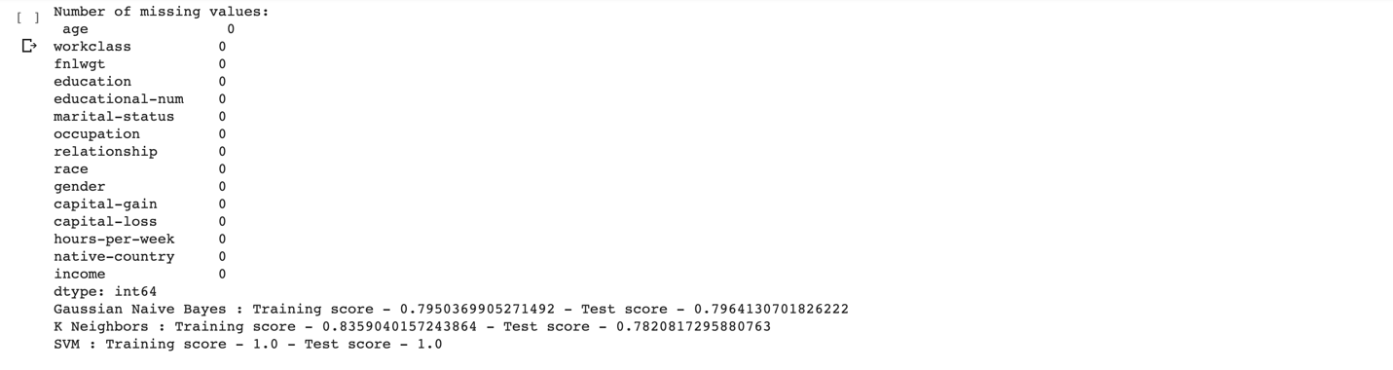

**Problem 6:**

**Approach:**

Here we have loaded the data from the college dataset and seperated the class and features. Replaced the null values with mean values, standardized the dataset and applied K-Means and elbow method on the dataset.

**Problem-7:**

**Approach:**

In this problem, we have written the code to read the data from a file, tokenize the data and applied lemmatization techniques and extracted all the trigrams for the words. And from these extracted trigrams we have concatenated the sentences with the most repeated trigrams and printed the result.

**Problem 8:**

**Approach:**

In this problem we have taken the college dataset and created multiple regression by calculating the null count, replacing null values with mean values and evaluated the performance and visualization results.



